Advanced Algebra Name: _______________________
Worksheet 6.8 Period: ______

Estimate the turning points of the graph and state whether each corresponds to a local maximum or minimum. Then state the zeros and the least degree the graph can have.
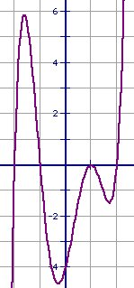
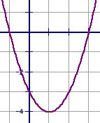
1. 2.

Turning points: _________________ Turning points: _______________
Zeros: __________ Zeros: __________
Least degree: __________ Least degree: __________

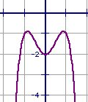
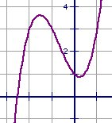
3. 4.

Turning points: _________________ Turning points: _______________
Zeros: __________ Zeros: __________
Least degree: __________ Least degree: __________

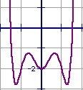
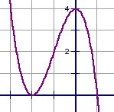
5. 6.

Turning points: _________________ Turning points: _______________
Zeros: __________ Zeros: __________
Least degree: __________ Least degree: __________

Match the graph with its function.

7. 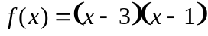 _____ 8. 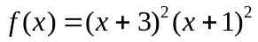 _____ 9. 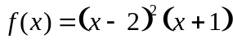 _____

10. 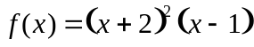 _____ 11. 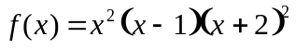 _____ 12. 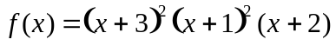____

13. 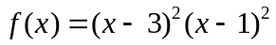 _____ 14. 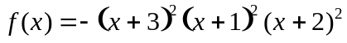 _____
A.
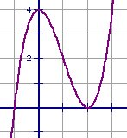
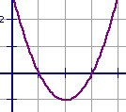
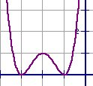
C.
B.

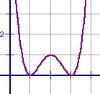
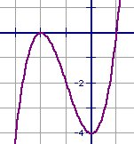
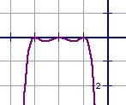
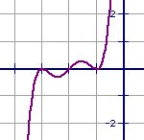
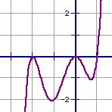
D.
E.
F.
G.
H.

